Objectives:

**Project #3:** complete the following program below. Research the most popular names on the Internet.

Create two files and enter up to 5 girls’ and boys’ names. The first file will have 5 girls’ names and the second file will have 5 boys’ names.

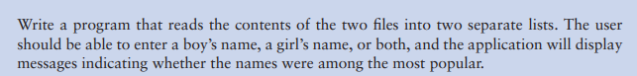

**#3 Print screen the output with the code below here.**

**Submit this document to Module 4 homework.**